Assessment 1

You are going to create a Music application which looks like the screenshot below.

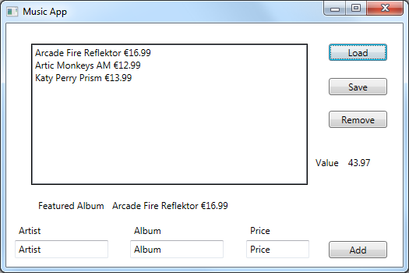

€43.97

|  |  |  |  |  |  |  |  |  |  |  |  |  |  |  |  |  |  |  |  |  |  |  |  |
| --- | --- | --- | --- | --- | --- | --- | --- | --- | --- | --- | --- | --- | --- | --- | --- | --- | --- | --- | --- | --- | --- | --- | --- |
| **Functionality**  Tasks you need to complete   1. Create the GUI 2. Create an Album class with the following attributes  * Album * Artist * Price  1. You should be able to add Album information using the controls at the bottom of the screen 2. You should be able to delete album information by selecting an item in the listbox and clicking remove. 3. The Value field should keep an updated total of the prices displayed 4. You should be able to load album information from a text file. 5. On file load you should use Random to select a random album and display this below the listbox 6. You should be able to save the listbox information to a text file | **Marking Scheme**   |  |  | | --- | --- | | GUI Layout | 5 | | Album Class | 10 | | Add Button | 5 | | Random Album | 5 | | Remove Button | 5 | | Running total | 5 | | File Load | 5 | | File Save | 5 | | Style/Comments etc. | 5 | |  |  | |  | 50 | |